Project
  - Deadline: Monday 30/11/2026 @ 23:59
[Total Mark for this Assignment is 14]

Introduction to Database
IT244

Instructions:
- You must submit two separate copies (one Word file and one PDF file) using the Assignment Template on Blackboard via the allocated folder. These files must not be in compressed format.
- It is your responsibility to check and make sure that you have uploaded both the correct files.
- Zero mark will be given if you try to bypass the SafeAssign (e.g. misspell words, remove spaces between words, hide characters, use different character sets or languages other than English or any kind of manipulation).
- Email submission will not be accepted.
- You are advised to make your work clear and well-presented. This includes filling your information on the cover page.
- You must use this template, failing which will result in zero mark.
- You MUST show all your work, and text must not be converted into an image, unless specified otherwise by the question.
- Late submission will result in ZERO mark.
- The work should be your own, copying from students or other resources will result in ZERO mark.
- Use Times New Roman font for all your answers.
Student Details: CRN: ###
Name: NOUF MOHAMMED  Name: ###  Name: ###  Name: ### |  | ID: 240072397  ID: ###  ID: ###  ID: ###

Project Instructions
Learning Outcome(s):
LO3: Design a database starting from the conceptual design to the implementation of database schemas.

LO4: Create Entity-Relationship model, Relational model, and write SQL queries.

- This project is a group work (minimum 3 and maximum 4 students).
- Only group leader submits the project through black board. (Email submission will not be accepted which will be awarded ZERO marks)
a | Identify the entity types, attributes, keys | 2 marks
b | Identify the relationship and cardinalities | 2 marks
c | Draw the ERD | 2 marks
d | Schemas before Normalization | 1.5 marks
e | Schemas after Normalization | 1.5 marks
f | Create the tables | 1.5 marks
g | Populate your tables with at least 5 rows | 1.5 marks
h | Execute the requested sample queries | 2 marks
- The project worth 14 marks and will be distributed as in the following:

- Screenshots for answering SQL questions (f, g, and h).
- The work must be clear and well presented; marks may be reduced for poor presentation.
- You MUST show all your work, and text must not be converted into an image, unless specified otherwise by the question.
- The work should be your own, copying from students or other resources will result in ZERO marks.
- Late submission will result in deduction of the total mark of the project.

PawCare Management System
Read the case study carefully. Every entity, attribute and relationship you need is mentioned in the text or the business rules. Do not add entities that are not described.

PawCare is a small veterinary clinic in Riyadh. The clinic currently keeps all its records on paper and in spreadsheets, and it wants a database to manage its owners, pets, veterinarians, appointments and medicines.

Owners: Every pet owner who visits the clinic is registered with a unique owner ID, a full name (first name and last name), an email and an address (street and city). An owner may give the clinic one or more phone numbers.

Pets: An owner can register one or more pets. Each pet has a unique pet ID, a name, a species (for example, cat, dog or bird), a breed and a date of birth. The clinic also wants to know each pet's age, which can be calculated from the date of birth. Each pet belongs to exactly one owner.

Veterinarians: The clinic employs several veterinarians (vets). Each vet has a unique vet ID, a name, a specialization (for example, surgery, dentistry or general care), a hire date and a monthly salary.

Appointments: Owners book appointments for their pets. Each appointment has a unique appointment ID, a date, a time, a reason for the visit and a fee. Each appointment is for exactly one pet and is handled by exactly one vet. A pet can have many appointments over time, and a vet handles many appointments.
Medicines and prescriptions: The clinic keeps a stock of medicines. Each medicine has a unique medicine code, a name, a unit price and a quantity in stock. During an appointment, the vet may prescribe one or more medicines. The same medicine can be prescribed in many different appointments. For each medicine prescribed in an appointment, the clinic records the dosage (i.e., "1 tablet twice a day") and the number of days the medicine should be taken.

PawCare Rules:
1. An owner owns one or more pets; a pet is owned by exactly one owner.
2. A pet can have zero or many appointments; an appointment is for exactly one pet.
3. A vet can handle zero or many appointments; an appointment is handled by exactly one vet.
4. An appointment can include zero or many prescribed medicines; a medicine can be prescribed in zero or many appointments.
5. Dosage and number of days belong to the prescription of a specific medicine in a specific appointment, not to the medicine itself.
6. An owner can have more than one phone number.
7. The appointment fee and the medicine unit price must be greater than zero.
8. The quantity in stock cannot be negative.

a) Entity types, attributes, keys
2 Marks
List every entity type in the case study. For each one, list its attributes and underline the primary key. Classify each attribute as simple, composite, multivalued or derived where this applies.
Entity Type | Attributes |  | Primary Key
Entity Type | Name | Type | Primary Key
Owner | OwnerID | Simple | OwnerID
Owner | FullName (FirstName, LastName) | Composite | -
Owner | Email | Simple | -
Owner | Address (Street, City) | Composite | -
Owner | PhoneNumber | Multivalued | -
Pet | PetID | Simple | PetID
Pet | PetName | Simple | -
Pet | Species | Simple | -
Pet | Breed | Simple | -
Pet | DateOfBirth | Simple | -
Pet | Age | Derived | -
Veterinarian | VetID | Simple | VetID
Veterinarian | VetName | Simple | -
Veterinarian | Specialization | Simple | -
Veterinarian | HireDate | Simple | -
Veterinarian | MonthlySalary | Simple | -
Appointment | AppointmentID | Simple | AppointmentID
Appointment | AppointmentDate | Simple | -
Appointment | AppointmentTime | Simple | -
Appointment | Reason | Simple | -
Appointment | Fee | Simple | -
Medicine | MedicineCode | Simple | MedicineCode
Medicine | MedicineName | Simple | -
Medicine | UnitPrice | Simple | -
Medicine | QuantityInStock | Simple | -

b) Relationships and cardinalities
2 Marks
List every relationship between the entities. For each one, state the cardinality ratio (1:1, 1:N or M:N) and the participation (total or partial from each side). If a relationship has its own attributes, list them.
Relationship Type | Entities connected by relationship type | Cardinality | Participation | Relationship attributes
Owns | Owner - Pet | 1:N | Owner: Total, Pet: Total | None
Has Appointments | Pet - Appointments | 1:N | Pet: Partial, Appointment: Total | None
Handles | Veterinarian – Appointment | 1:N | Veterinarian: Partial, Appointment: Total | None
Prescribes | Appointment – Medicine | N:M | Appointment: Partial, Medicine: Partial | Dosage, NumberOfDays

c) PawCare ERD
2 Marks
Draw one complete ER diagram that shows all entities, attributes, keys, relationships, cardinalities and participation constraints.

d) Schemas before Normalization
1.5 Marks
Map your ERD to relational schemas using the mapping steps taught in the lectures. Write each schema in the form TABLE_NAME(Attribute1, Attribute2, …), underline the primary key and mark foreign keys with an asterisk (*).

1. OWNERS
OWNERS(OwnerID, FirstName, LastName, Email, Street, City)

2. OWNER_PHONES
OWNER_PHONES(OwnerID*, PhoneNumber)

3. PETS
PETS(PetID, PetName, Species, Breed, DateOfBirth, OwnerID*)

4. VETERINARIANS
VETERINARIANS(VetID, VetName, Specialization, HireDate, MonthlySalary)

5. APPOINTMENTS
APPOINTMENTS(AppointmentID, AppointmentDate, AppointmentTime, Reason, Fee, PetID*, VetID*)

6. MEDICINES
MEDICINES(MedicineCode, MedicineName, UnitPrice, QuantityInStock)

7. PRESCRIPTIONS
PRESCRIPTIONS(AppointmentID*, MedicineCode*, Dosage, NumberOfDays)

e) Schemas after Normalization
1.5 Marks
Check each schema from part (d) against 1NF, 2NF and 3NF. For every schema that violates a normal form, explain the violation in one sentence and show the decomposed schemas. Your final set of schemas must be in 3NF.
Schema | Violation | Reason | How to fix
OWNERS | None | All non-key attributes depend on OwnerID | No changes required
OWNER_PHONES | None | Each row stores one phone number, identified by the composite key | No changes required
PETS | None | All non-key attributes depend on PetID | No changes required
VETERINARIANS | None | All non-key attributes depend on VetID | No changes required
APPOINTMENTS | None | All non-key attributes depend on AppointmentID | No changes required
MEDICINES | None | All non-key attributes depend on MedicineCode | No changes required
PRESCRIPTIONS | None | Dosage and NumberOfDays depend on the complete composite key | No changes required

All schemas satisfy 1NF, 2NF, and 3NF. Each table contains atomic values, all non-key attributes depend on the complete primary key, and there are no transitive dependencies. Therefore, no further decomposition is required.

Final schemas after Normalization for PawCare:
OWNERS(OwnerID, FirstName, LastName, Email, Street, City)

OWNER_PHONES(OwnerID*, PhoneNumber)

PETS(PetID, PetName, Species, Breed, DateOfBirth, OwnerID*)

VETERINARIANS(VetID, VetName, Specialization, HireDate, MonthlySalary)

APPOINTMENTS(AppointmentID, AppointmentDate, AppointmentTime, Reason, Fee, PetID*, VetID*)

MEDICINES(MedicineCode, MedicineName, UnitPrice, QuantityInStock)

PRESCRIPTIONS(AppointmentID*, MedicineCode*, Dosage, NumberOfDays)

f) Create SQL tables
1.5 Marks
Write the CREATE TABLE statements for your final 3NF schemas. Every table must have a PRIMARY KEY. Use FOREIGN KEY constraints for all relationships, NOT NULL for required attributes and CHECK constraints. Make sure to create the tables in the correct order so that every referenced table exists first.

PRAGMA foreign_keys = ON;

CREATE TABLE OWNERS (
OwnerID INTEGER PRIMARY KEY,
FirstName TEXT NOT NULL,
LastName TEXT NOT NULL,
Email TEXT NOT NULL,
Street TEXT NOT NULL,
City TEXT NOT NULL
);

CREATE TABLE VETERINARIANS (
VetID INTEGER PRIMARY KEY,
VetName TEXT NOT NULL,
Specialization TEXT NOT NULL,
HireDate TEXT NOT NULL,
MonthlySalary REAL NOT NULL
CHECK (MonthlySalary > 0)
);

CREATE TABLE MEDICINES (
MedicineCode TEXT PRIMARY KEY,
MedicineName TEXT NOT NULL,
UnitPrice REAL NOT NULL
CHECK (UnitPrice > 0),
QuantityInStock INTEGER NOT NULL
CHECK (QuantityInStock >= 0)
);

CREATE TABLE OWNER_PHONES (
OwnerID INTEGER NOT NULL,
PhoneNumber TEXT NOT NULL,
PRIMARY KEY (OwnerID, PhoneNumber),
FOREIGN KEY (OwnerID)
REFERENCES OWNERS(OwnerID)
);

CREATE TABLE PETS (
PetID INTEGER PRIMARY KEY,
PetName TEXT NOT NULL,
Species TEXT NOT NULL,
Breed TEXT NOT NULL,
DateOfBirth TEXT NOT NULL,
OwnerID INTEGER NOT NULL,
FOREIGN KEY (OwnerID)
REFERENCES OWNERS(OwnerID)
);

CREATE TABLE APPOINTMENTS (
AppointmentID INTEGER PRIMARY KEY,
AppointmentDate TEXT NOT NULL,
AppointmentTime TEXT NOT NULL,
Reason TEXT NOT NULL,
Fee REAL NOT NULL CHECK (Fee > 0),
PetID INTEGER NOT NULL,
VetID INTEGER NOT NULL,
FOREIGN KEY (PetID)
REFERENCES PETS(PetID),
FOREIGN KEY (VetID)
REFERENCES VETERINARIANS(VetID)
);

CREATE TABLE PRESCRIPTIONS (
AppointmentID INTEGER NOT NULL,
MedicineCode TEXT NOT NULL,
Dosage TEXT NOT NULL,
NumberOfDays INTEGER NOT NULL
CHECK (NumberOfDays > 0),
PRIMARY KEY (AppointmentID, MedicineCode),
FOREIGN KEY (AppointmentID)
REFERENCES APPOINTMENTS(AppointmentID),
FOREIGN KEY (MedicineCode)
REFERENCES MEDICINES(MedicineCode)
);
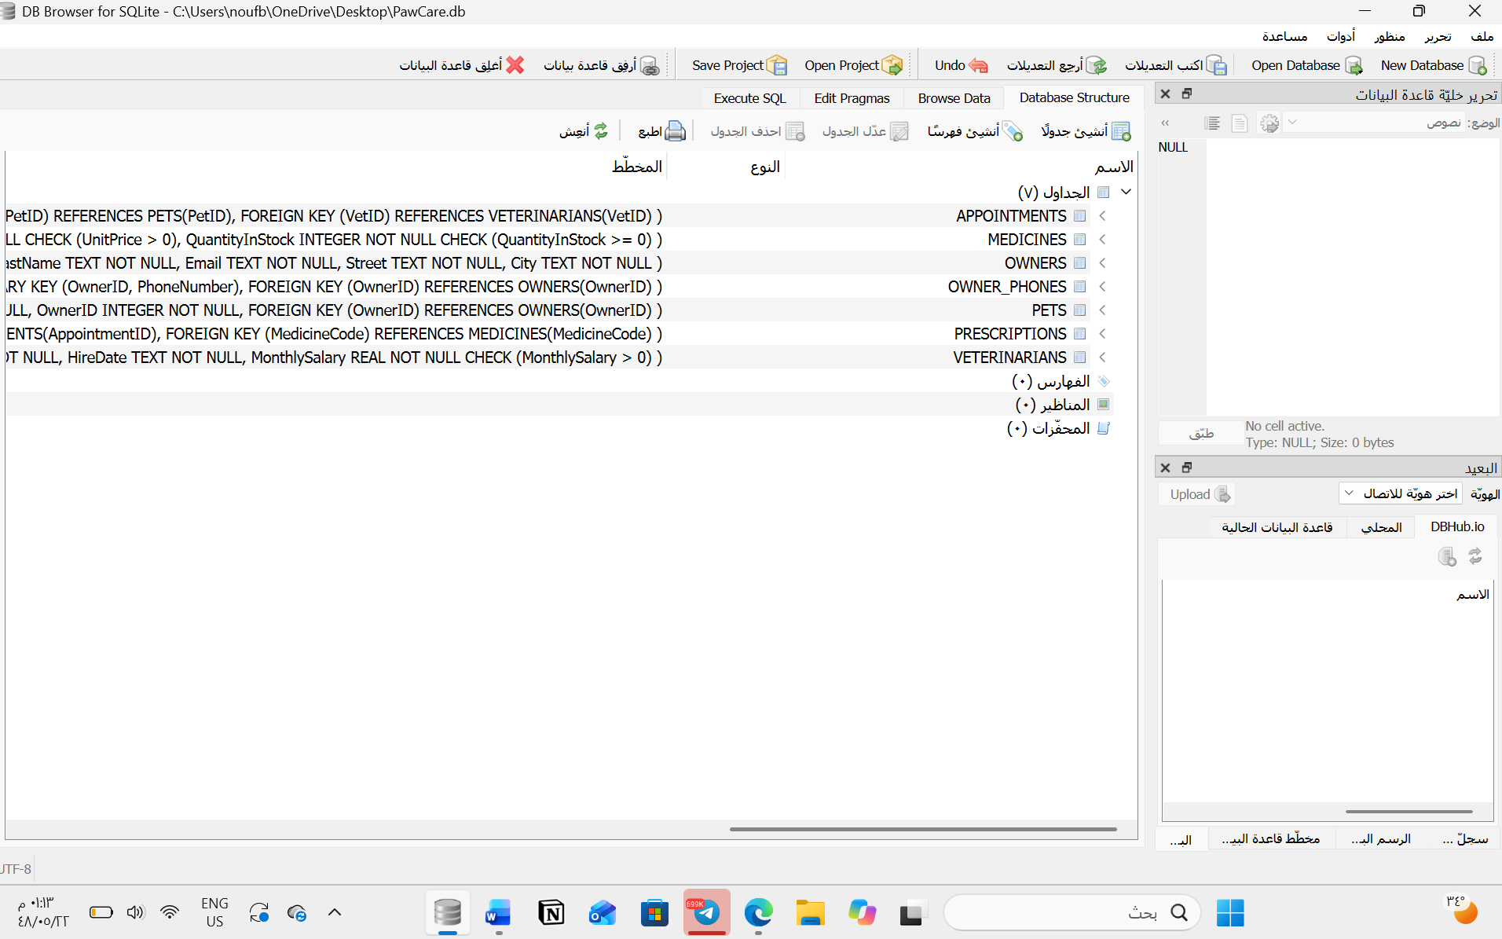

g) Populate tables
1.5 Marks
Insert at least 5 rows into every table using INSERT statement. Choose your data so that it can be retrieved when applying the quires in the next question part (h).
1. OWNERS Table
INSERT INTO OWNERS
(OwnerID, FirstName, LastName, Email, Street, City)
VALUES
(1, 'Ahmed', 'Ali', 'ahmed@example.com', 'King Fahd Road', 'Riyadh'),
(2, 'Sara', 'Mohammed', 'sara@example.com', 'Olaya Street', 'Riyadh'),
(3, 'Khalid', 'Hassan', 'khalid@example.com', 'Tahlia Street', 'Riyadh'),
(4, 'Noura', 'Saleh', 'noura@example.com', 'King Abdullah Road', 'Riyadh'),
(5, 'Fahad', 'Omar', 'fahad@example.com', 'Anas Bin Malik Road', 'Riyadh');
Screenshot 1: OWNERS table containing five records.
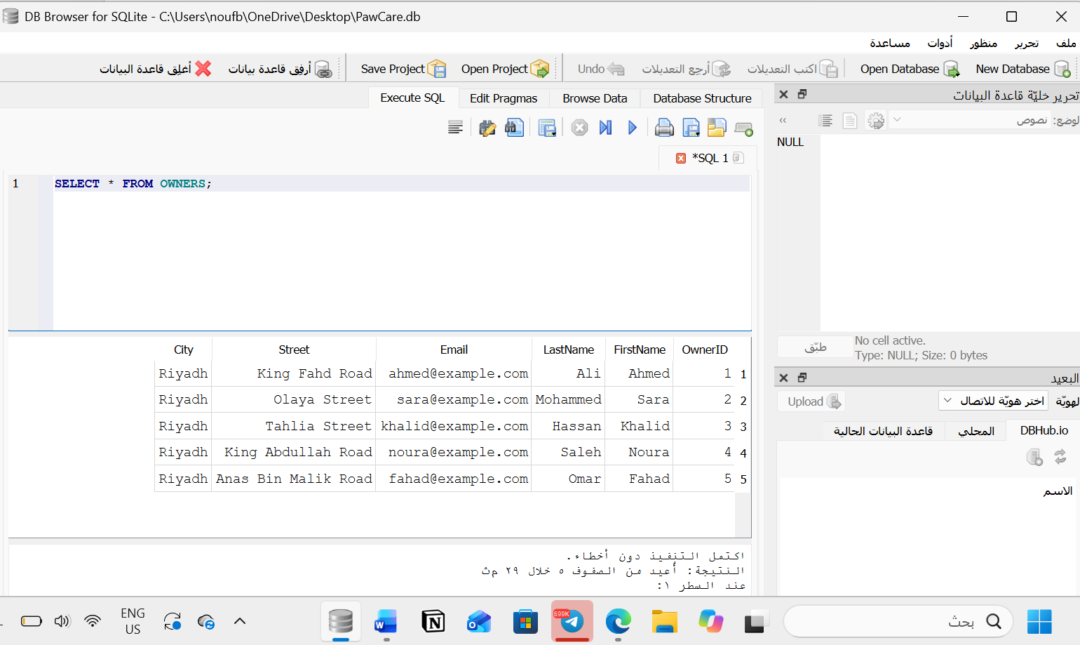

2. OWNER_PHONES Table
INSERT INTO OWNER_PHONES
(OwnerID, PhoneNumber)
VALUES
(1, '0501111111'),
(2, '0502222222'),
(3, '0503333333'),
(4, '0504444444'),
(5, '0505555555');
Screenshot 2: OWNER_PHONES table containing five records.
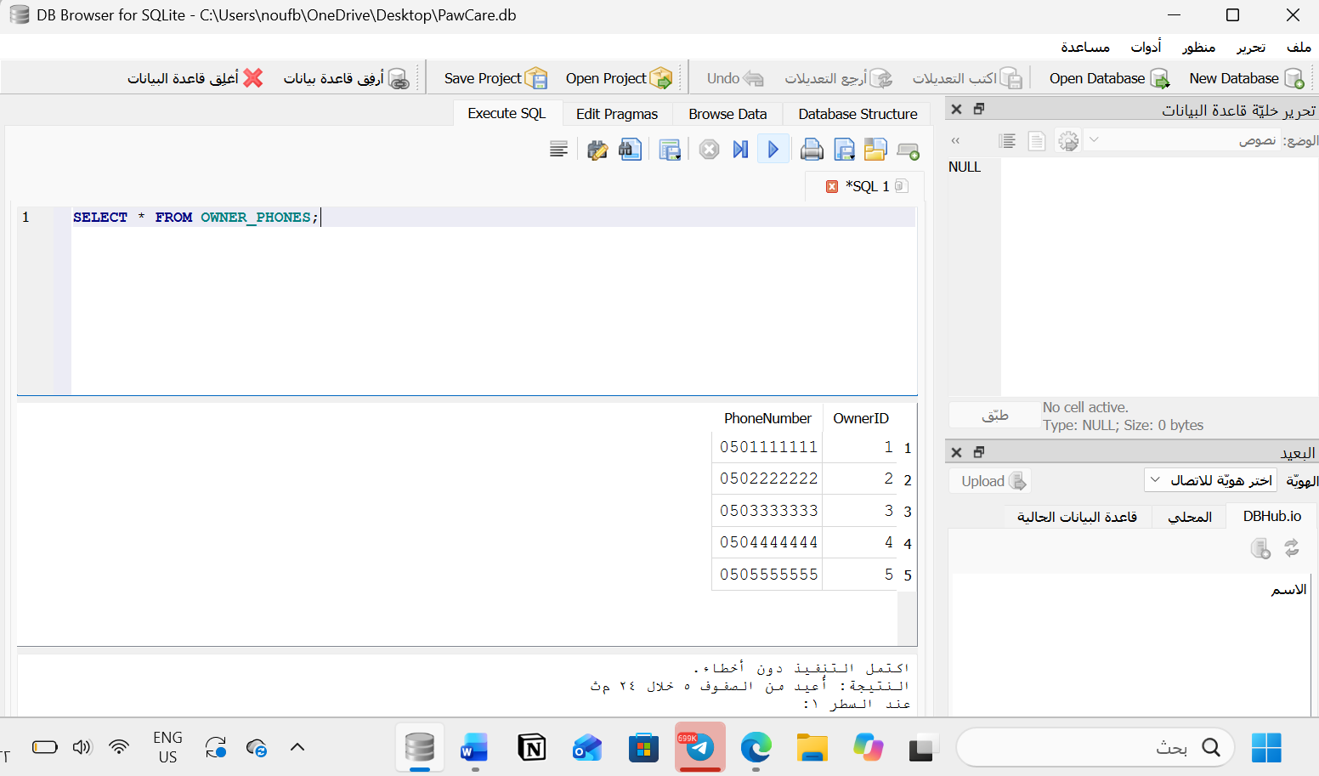

3. PETS Table
INSERT INTO PETS
(PetID, PetName, Species, Breed, DateOfBirth, OwnerID)
VALUES
(1, 'Luna', 'Cat', 'Persian', '2022-05-10', 1),
(2, 'Max', 'Dog', 'Golden Retriever', '2021-08-15', 2),
(3, 'Milo', 'Cat', 'Siamese', '2023-02-20', 3),
(4, 'Coco', 'Bird', 'Parrot', '2024-01-12', 4),
(5, 'Bella', 'Cat', 'British Shorthair', '2022-11-05', 5);
Screenshot 3: PETS table containing five records.
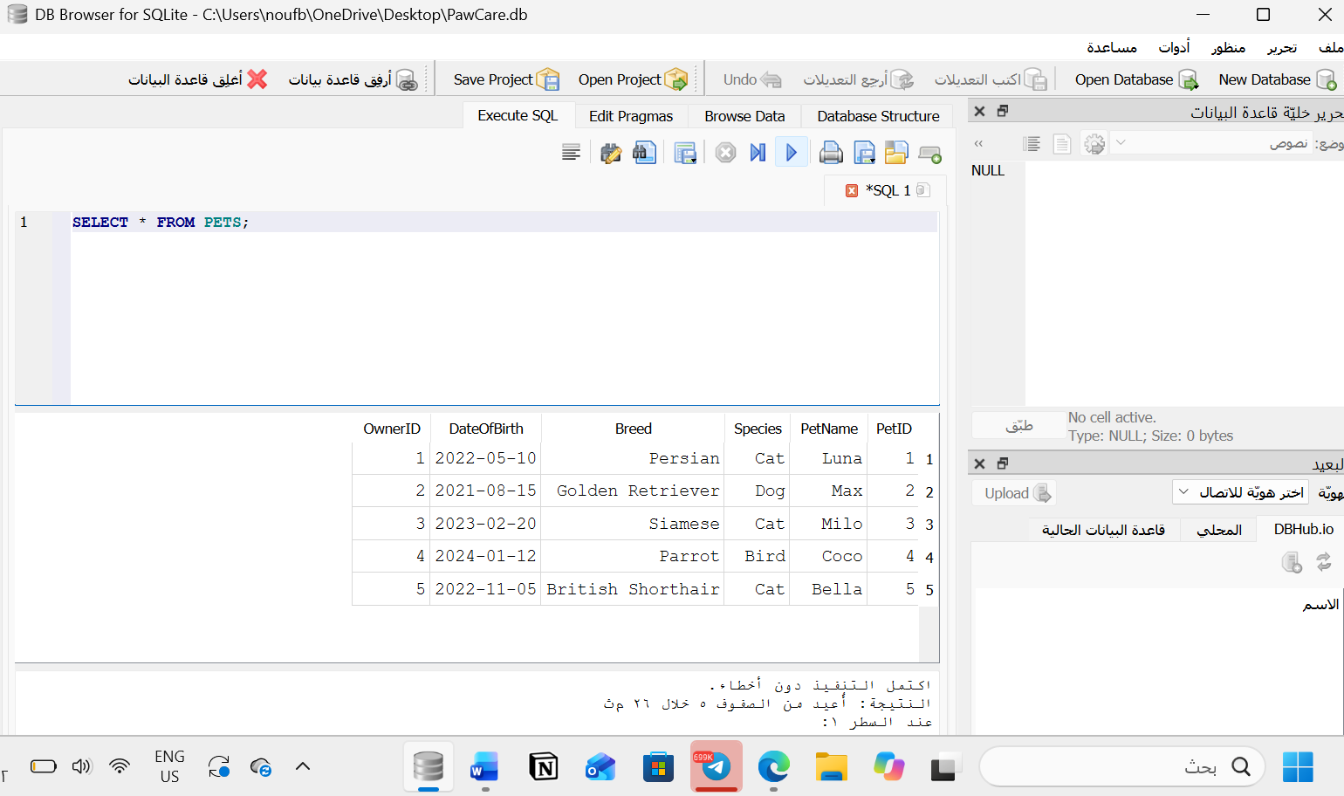

4. VETERINARIANS Table
INSERT INTO VETERINARIANS
(VetID, VetName, Specialization, HireDate, MonthlySalary)
VALUES
(1, 'Dr. Sara Ahmed', 'General Care', '2020-03-15', 12000),
(2, 'Dr. Omar Khalid', 'Surgery', '2019-06-10', 15000),
(3, 'Dr. Layla Hassan', 'Dentistry', '2021-09-20', 13000),
(4, 'Dr. Fahad Ali', 'General Care', '2022-01-12', 11000),
(5, 'Dr. Noura Saleh', 'Surgery', '2018-11-05', 16000);
Screenshot 4: VETERINARIANS table containing five records.
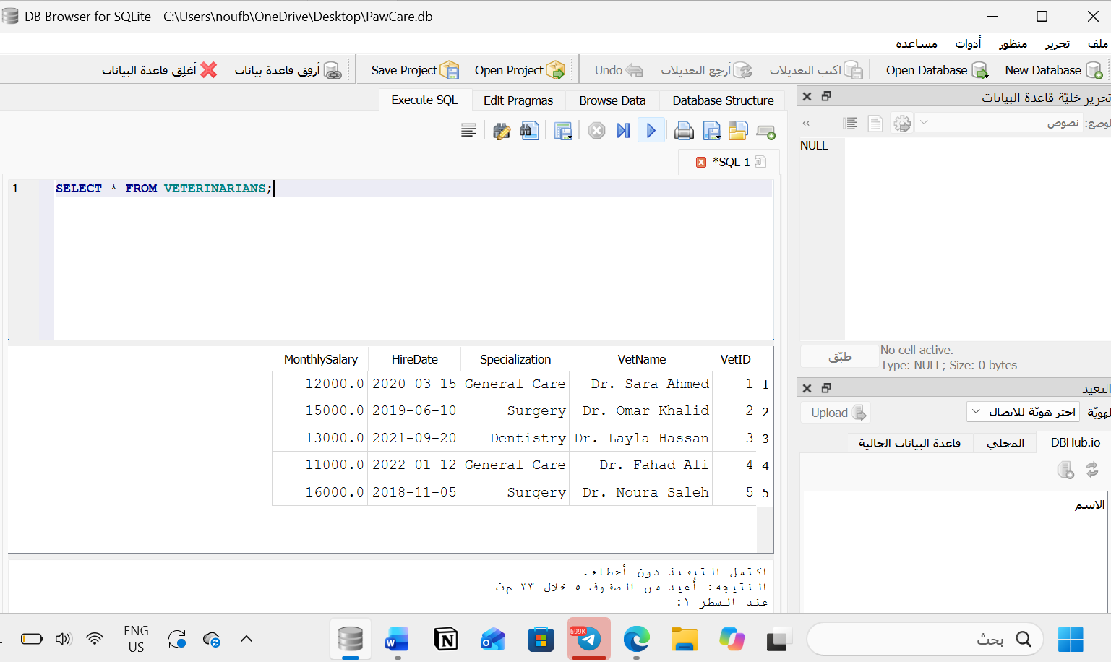

5. MEDICINES Table
INSERT INTO MEDICINES
(MedicineCode, MedicineName, UnitPrice, QuantityInStock)
VALUES
('M001', 'Amoxicillin', 45.00, 10),
('M002', 'Paracetamol', 20.00, 50),
('M003', 'Vitamin Supplement', 35.00, 15),
('M004', 'Antibiotic Cream', 30.00, 8),
('M005', 'Deworming Tablets', 25.00, 40);
Screenshot 5: MEDICINES table containing five records.
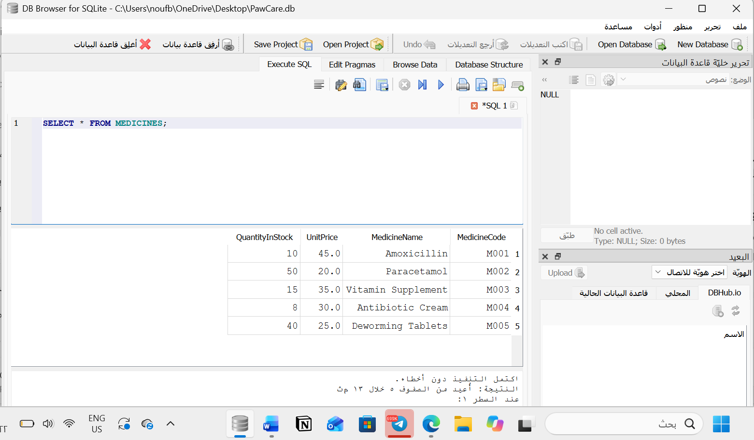

6. APPOINTMENTS Table
INSERT INTO APPOINTMENTS
(AppointmentID, AppointmentDate, AppointmentTime, Reason, Fee, PetID, VetID)
VALUES
(1, '2026-11-02', '09:00:00', 'General Checkup', 150, 1, 1),
(2, '2026-11-05', '10:30:00', 'Vaccination', 200, 2, 2),
(3, '2026-11-10', '11:00:00', 'Dental Checkup', 180, 3, 3),
(4, '2026-12-01', '13:00:00', 'Routine Checkup', 150, 4, 4),
(5, '2026-11-15', '14:30:00', 'Skin Treatment', 250, 5, 5);
Screenshot 6: APPOINTMENTS table containing five records.
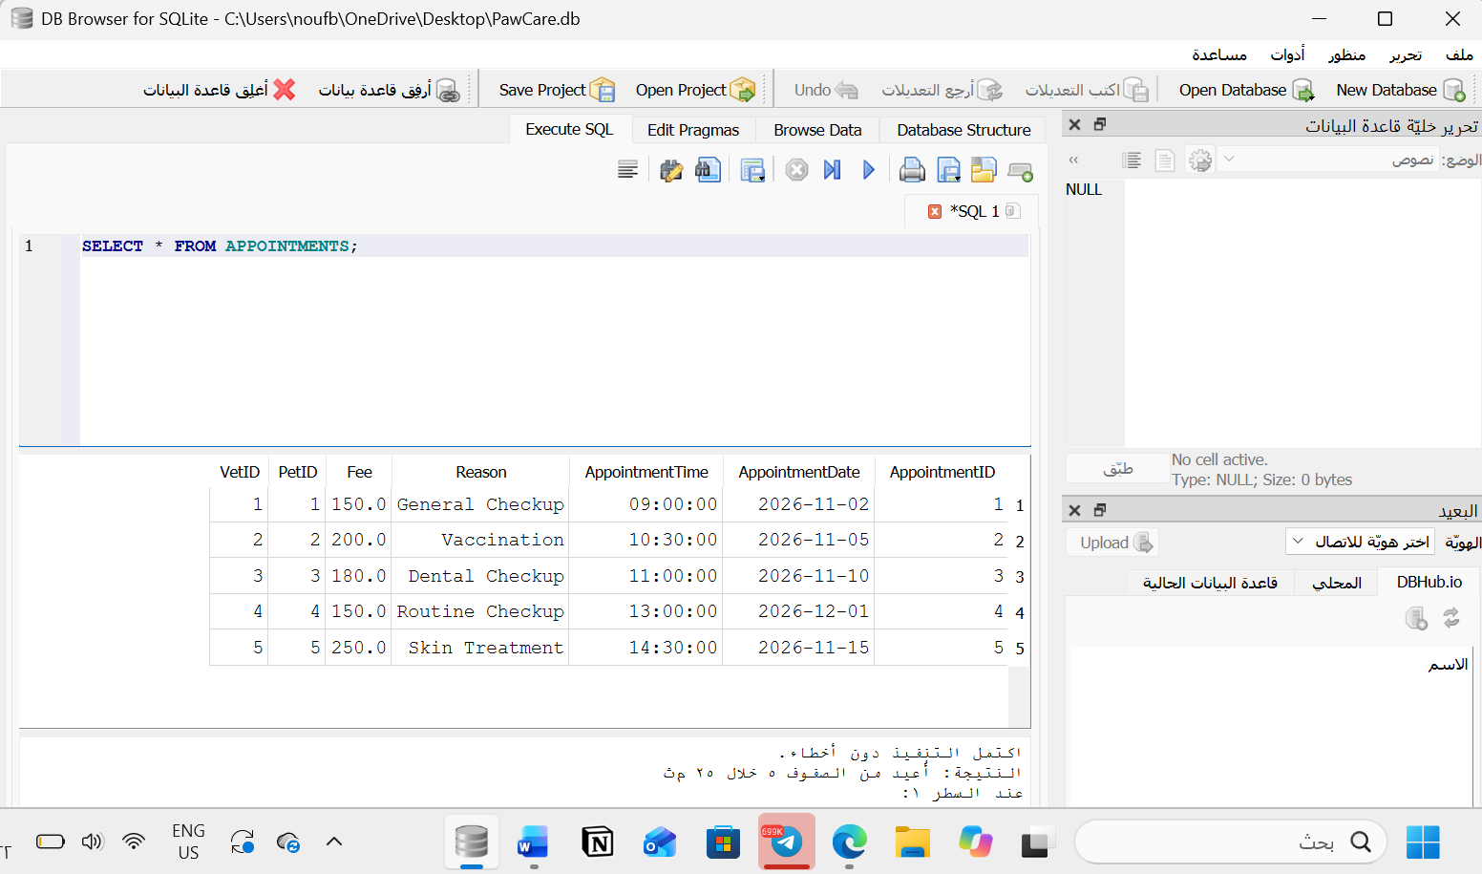

7. PRESCRIPTIONS Table
INSERT INTO PRESCRIPTIONS
(AppointmentID, MedicineCode, Dosage, NumberOfDays)
VALUES
(1, 'M001', '1 tablet twice a day', 7),
(2, 'M003', '5 ml once a day', 5),
(3, 'M002', '1 tablet once a day', 3),
(4, 'M005', '1 tablet daily', 5),
(5, 'M004', 'Apply twice a day', 10);
Screenshot 7: PRESCRIPTIONS table containing five records.
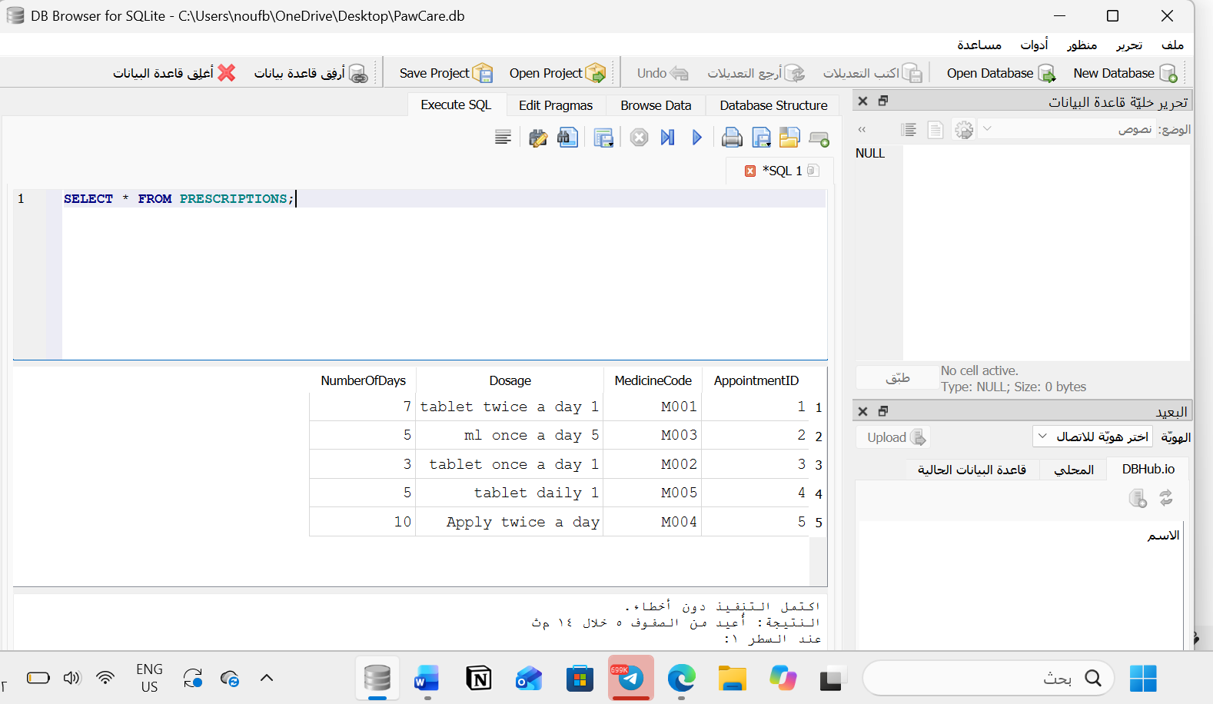

h) Sample queries execution
2 Marks
Write and execute an SQL statement for each request below. For each one, submit the SQL code and a screenshot of its output.
- Display all pets whose species is "Cat", sorted by pet name.
- Display each pet's name together with its owner's first and last name.
- Display the appointment ID, date, pet name and vet name for all appointments in a month of your choice.
- Display the medicines whose quantity in stock is less than 20.

1)Display all pets whose species is "Cat", sorted by pet name.
SELECT *
FROM PETS
WHERE Species = 'Cat'
ORDER BY PetName ASC;
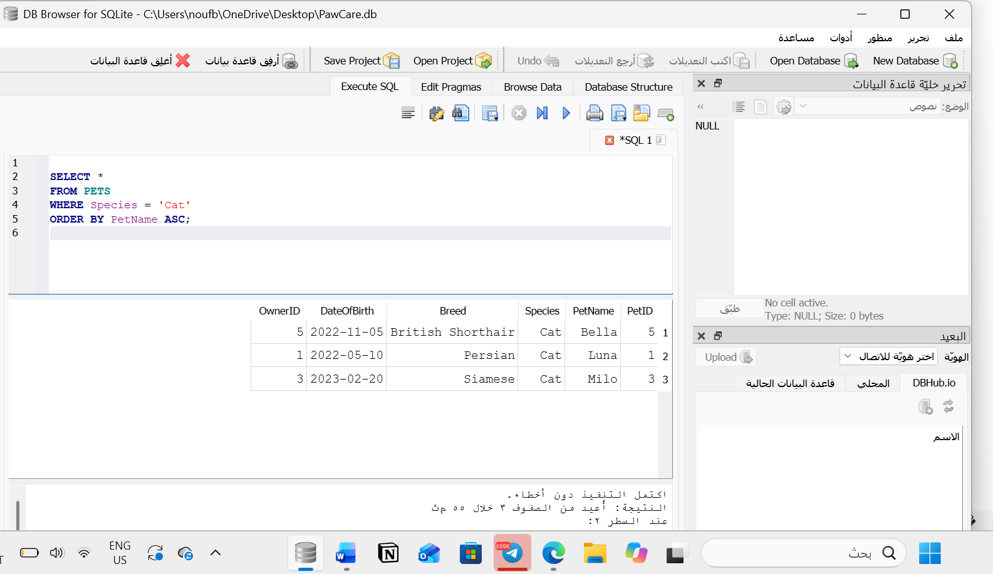

- Display each pet's name together with its owner's first and last name.

SELECT
PETS.PetName,
OWNERS.FirstName,
OWNERS.LastName
FROM PETS
INNER JOIN OWNERS
ON PETS.OwnerID = OWNERS.OwnerID;
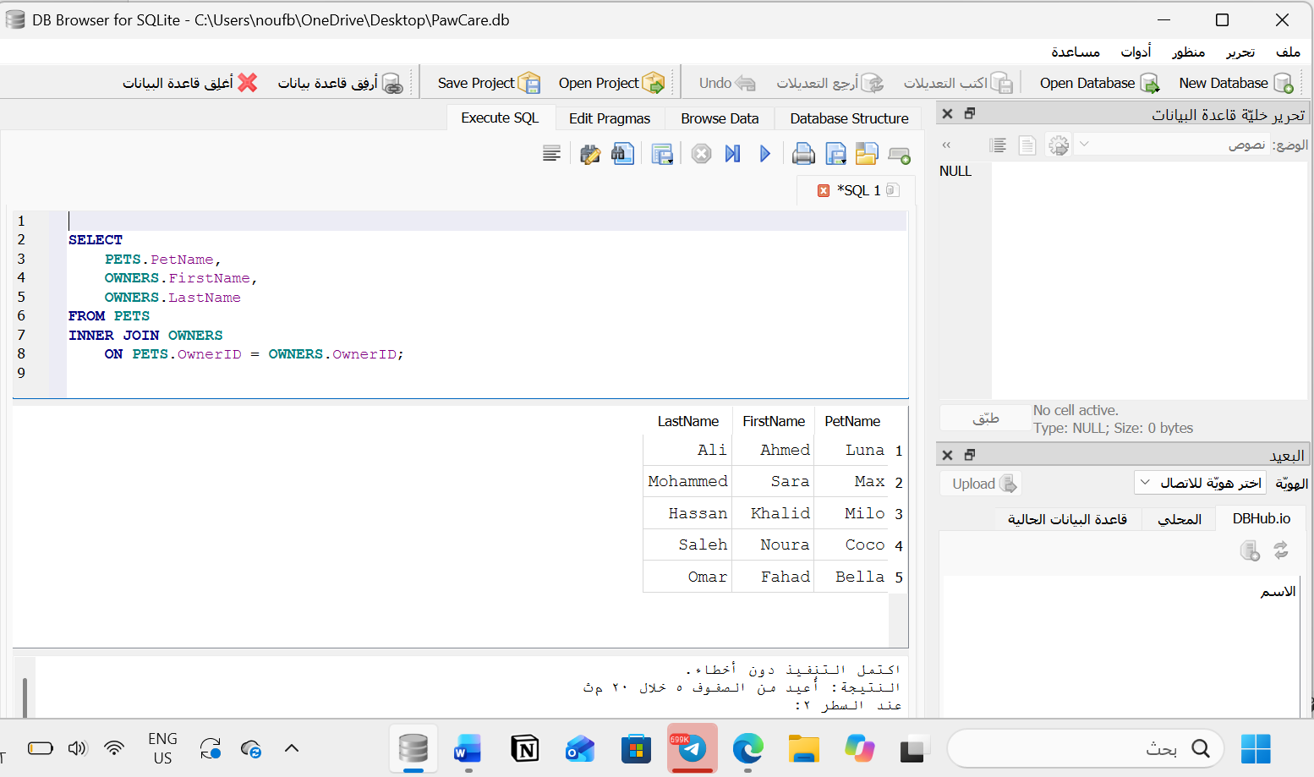

- Display the appointment ID, date, pet name and vet name for all appointments in a month of your choice.

SELECT
APPOINTMENTS.AppointmentID,
APPOINTMENTS.AppointmentDate,
PETS.PetName,
VETERINARIANS.VetName
FROM APPOINTMENTS
INNER JOIN PETS
ON APPOINTMENTS.PetID = PETS.PetID
INNER JOIN VETERINARIANS
ON APPOINTMENTS.VetID = VETERINARIANS.VetID
WHERE APPOINTMENTS.AppointmentDate
BETWEEN '2026-11-01' AND '2026-11-30'
ORDER BY APPOINTMENTS.AppointmentDate ASC;

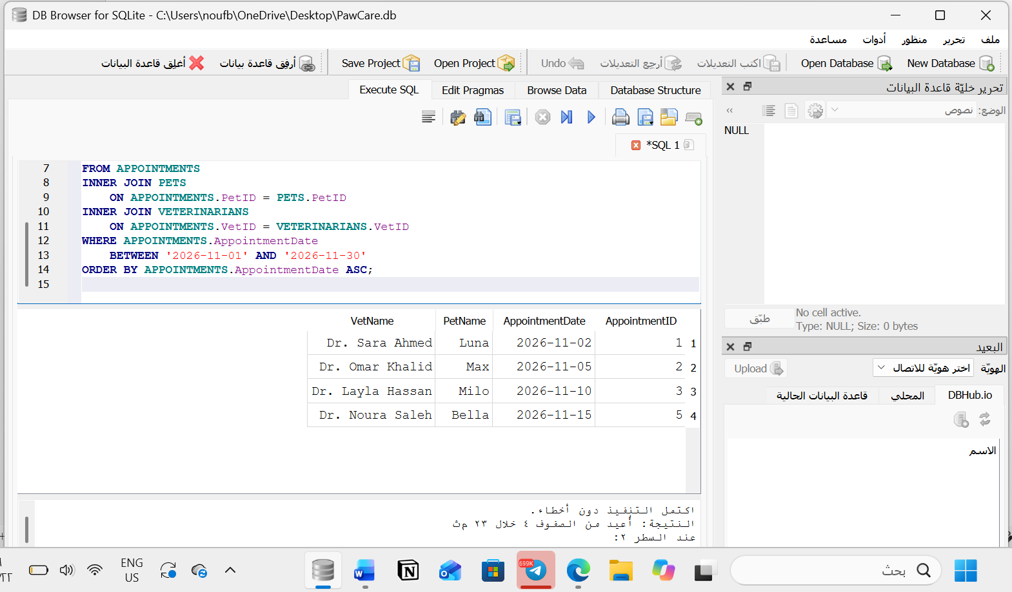

- Display the medicines whose quantity in stock is less than 20.

SELECT *
FROM MEDICINES
WHERE QuantityInStock < 20;


